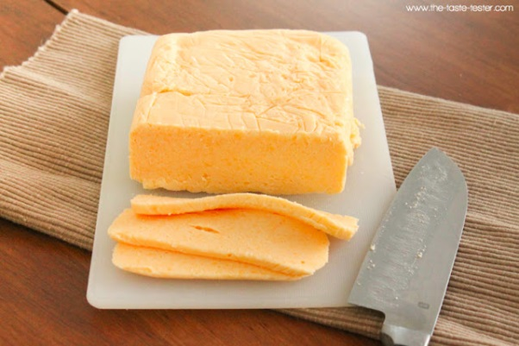

HOMEMADE VELVEETA CHEESE

1 tablespoon water
1 1/2 teaspoons powdered gelatin (unflavored)
12 ounces Cheese (See Variables below)
1 tablespoon non-fat or whole dry milk powder
3/4-1 teaspoon salt
1/8 teaspoon cream of tartar
1/2 cup + 2 tablespoons whole milk

Line a 5x4 inch disposable aluminum bread pan with plastic wrap, allowing some plastic wrap to hang over the edges.

Place water in a small bowl and sprinkle gelatin over the top of the water. Let sit at least 5 minutes.

Weigh cheese and then shred. Pulse cheese, dry milk, salt, and cream of tartar together in the bowl of a food processor until combined (3-5 pulses). Start with 3/4 teaspoon of salt. Once you have added the milk you can taste it and determine if more salt is needed.

Meanwhile bring milk to a boil over medium high heat. Once it reaches a boil, remove from heat and stir in prepared gelatin until dissolved. Pour hot milk into a liquid measuring cup with spout. With food processor running, gradually add hot milk. Process mixture until it is thoroughly combined and velvety smooth.

Immediately pour into prepared pan, folding excess plastic wrap over the top of the cheese mixture. Chill for at least three hours or overnight.

RR: 3 Year Cheddar

BF: 2 Year Cheddar

AB: Extra Sharp

DG: Sharp

GF: Medium

PD: Colby

